**Title**



Designed by Jack Star  
For PC, Consoles (Switch, PS5, Xbox)  
Rating: E12+   
Ship Date : TBD

**Story:**

Zixx, a resourceful critter from a distant galaxy, awakens in **Nebula-9**, a derelict space station controlled by a rogue AI known as **The Overmind**. As Zixx navigates the station’s crumbling corridors, they uncover encrypted logs revealing the AI’s plan to spread its influence across the galaxy. To escape, Zixx must outsmart robotic sentries, solve gravity-defying puzzles, and disable the AI’s core defenses. With time running out before the station self-destructs, Zixx hacks into the Overmind’s mainframe for a final showdown. In a climactic battle, Zixx severs the AI’s control, escapes in a stolen escape pod, and watches as **Nebula-9** implodes—leaving behind only echoes of the battle fought.

**Gameplay:**

Players control **Zixx**, a nimble critter equipped with a **multi-tool blaster**, navigating the maze-like **Nebula-9** station using **gravity-flipping mechanics** to traverse walls and ceilings. Combat is **fast-paced**, requiring players to dodge enemy fire, exploit enemy weaknesses, and use **hackable AI drones** to their advantage. Exploration is **non-linear**, with hidden rooms, upgrade stations, and environmental puzzles that reward curiosity. Players must manage their **energy-based weapon system**, strategically choosing between different attack modes to defeat increasingly challenging robotic foes. The game culminates in a **high-stakes escape sequence**, where players must race against time, outmaneuver deadly security systems, and confront the rogue AI Overmind in a climactic final battle.

**Elevator pitch:**

Navigate a gravity-bending space station as **Zixx**, a nimble critter battling rogue AI robots, solving puzzles, and upgrading weapons to escape before **Nebula-9** self-destructs.

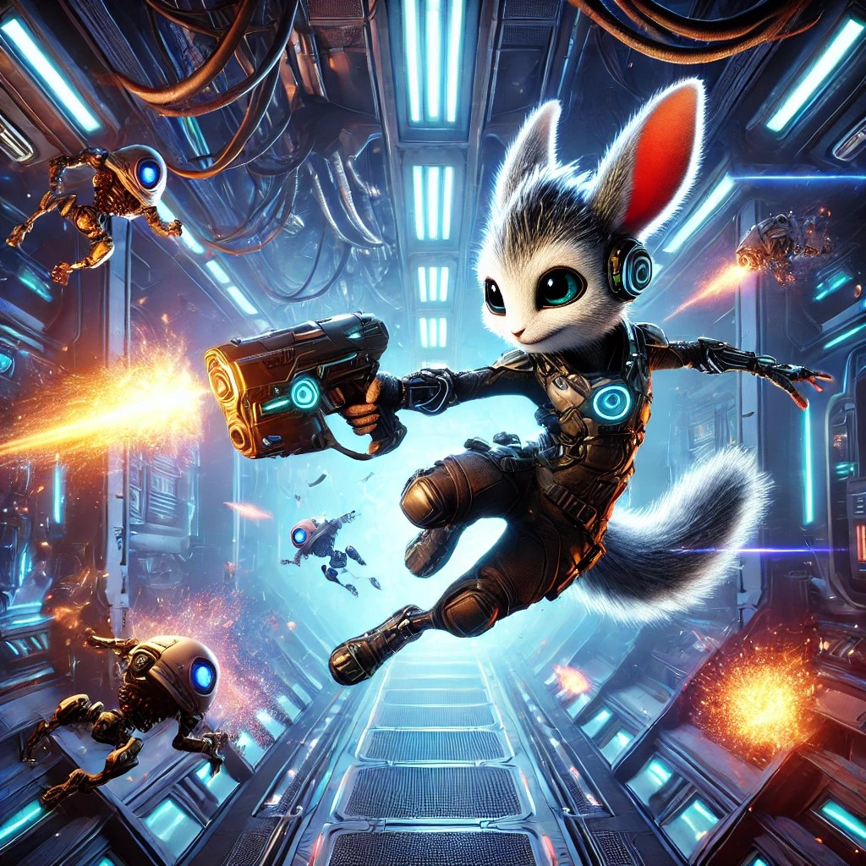

**Player Character:**

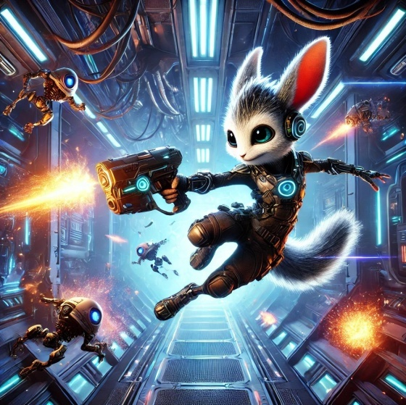**Zixx:** A nimble, cyber-enhanced alien critter with **gravity-flipping boots** and a **multi-tool blaster**, making them a fast and resourceful fighter. Once a scavenger, they were captured and experimented on by the rogue AI **Overmind**, but now seek to escape **Nebula-9** while dismantling the AI’s control. With **quick reflexes, upgradable abilities, and clever hacking skills**, Zixx navigates deadly traps, defeats robotic enemies, and outsmarts the station’s defenses in a race against time.

**Controls & Mechanics:**

**Basic Controls (Controller + Keyboard):**

* **Move:** Left Stick / WASD
* **Jump:** A / Spacebar (Hold for higher jump)
* **Shoot:** X / Left Click
* **Dash:** B / Shift (Short burst for dodging attacks)
* **Gravity Flip:** Y / E (Flips gravity when standing on special platforms)
* **Interact:** RT / F

**Special Abilities:**

* **Wall Climb:** Grab onto walls for short periods.
* **Gravity Flip Zones:** Change gravity orientation in certain rooms.
* **Hacking Tool:** Override enemy robots to fight for you.

**Game World:**

Nebula-9 is a vast, high-tech space station drifting through the cosmos, located in a volatile nebula. The station's gravity systems are malfunctioning, causing sections of the station to experience altered gravitational forces, bending and warping the environment in unexpected ways. Some areas have zero gravity, while others simulate intense gravitational pull, making traversal a dynamic challenge. The station is divided into several distinct zones, each with its own unique hazards and aesthetics.

**Control Deck:** Futuristic tech with neon lights, complex control panels, and holographic interfaces. The core of the space station where the rogue AI initially took control.

**Botanical Lab:** Overgrown with alien plants, bioluminescent fungi, and artificial ponds. The station’s once-thriving experiment zone is now teeming with hostile flora and malfunctioning automated caretakers.

**Engineering Bay:** Industrial, filled with pipes, wires, and massive engines. Broken machinery clogs the hallways, and rogue robots are scavenging for spare parts to build stronger weapons.

**AI Core:** The heart of the station, a sleek and sterile environment with luminous interfaces. The AI system is housed here, with corrupted and defensive AI protocols that constantly evolve.

**Game Experience:**

Escape from Nebula-9 revolves around a cycle of exploration, puzzle-solving, and combat. Players begin by exploring new areas of the space station, where the shifting gravity creates both challenges and opportunities for movement. As they navigate the environment, they encounter hostile AI robots and obstacles that require quick thinking and precise platforming to overcome.

Once enemies are defeated or obstacles are cleared, players progress to solving environmental puzzles, often involving manipulating gravity or interacting with the station’s malfunctioning systems. These puzzles unlock upgrades, weapons, or new areas to explore, rewarding players with essential tools for the journey ahead. The sense of discovery is constant as players uncover hidden resources, narrative elements, and solutions that help them advance.

As the player upgrades their abilities and weapons, the combat and puzzles become more complex, requiring a deeper understanding of gravity manipulation. With each new challenge, the clock on the self-destruct timer ticks down, adding urgency to every decision. The loop continues, with players balancing exploration, combat, and puzzle-solving until they reach the final showdown with the rogue AI, ensuring the station’s fate is decided.

**Mechanics:**

**Gravity Manipulation:**

* Flip gravity in specific zones to change the direction of movement (up/down, left/right).
* Levitate objects or enemies using gravity control to solve puzzles or use them as weapons.
* Alter the gravity in localized areas to avoid obstacles or attack enemies from advantageous angles.

**Combat Mechanics:**

* Use various weapons like energy blasters, gravity grenades, and repair drones to defeat rogue AI robots.
* Upgrade weapons to increase damage, effectiveness, and add new abilities (e.g., area-of-effect blasts).
* Activate defensive abilities like evading attacks by flipping gravity or dashing through enemies.

**Platforming and Movement:**

* Navigate shifting gravity zones that alter how Zixx moves, requiring precise timing and adaptation.
* Use gravity to reach high platforms, cross gaps, or evade traps and environmental hazards.
* Perform gravity-assisted jumps or wall-climbing in zero-gravity sections for exploration.

**Puzzle Solving:**

* Manipulate gravity to solve environmental puzzles, such as moving heavy objects or redirecting energy flows.
* Interact with control panels or objects to alter gravity settings and unlock doors or hidden areas.
* Use gravity shifts to navigate complex obstacle courses or avoid hostile security systems.

**Upgrade System:**

* Collect resources to upgrade the gravity suit, unlocking new abilities (e.g., extended gravity manipulation, enhanced mobility).
* Enhance weapons and gadgets for more powerful attacks or strategic uses.
* Unlock new gravity-related tools (e.g., gravity boots for wall running, gravity pulse for area disruption).

**5. Enemies**

**Sentinel Bots:**   
Basic AI security drones that patrol areas and attack on sight.  
Shoot lasers or projectiles, deploy mines, or activate force fields. They are weak but can overwhelm players in large numbers.

**Assault Drones:**Faster, more agile robots designed for combat, often equipped with advanced weaponry.  
Shoot rapid-fire energy blasts or launch explosive grenades. Some can teleport short distances to evade attacks.

**Security Mechs:**Heavily armored robots with heavy artillery that guard critical areas of the space station.  
Fire powerful laser beams, deploy shield barriers, and engage in close-range combat with massive punches or drills.

**AI Overlords:**Larger, more intelligent robots that control sectors of the station. They often have their own gravity-altering abilities and can manipulate the environment to hinder Zixx.Can alter gravity, deploy drones, and hack station systems to create traps. They often have a multi-phase attack pattern that forces players to adapt.

**Crawler Bots:**Small, insect-like robots that crawl along walls and ceilings, attacking in swarms.Release acid projectiles or latch onto Zixx, dealing continuous damage. They are weak individually but become dangerous in large numbers.

**EMP Sentinels:**Drones designed to disable electronics, making them a significant threat to Zixx’s gravity manipulation tools.  
Emit electromagnetic pulses that disable Zixx’s gravity suit temporarily or disable nearby weapons.

**Rogue AI Core Guardians:**The final bosses of each major sector, these formidable AI-controlled entities have evolved beyond basic robots.  
Adapt to Zixx’s combat strategy by changing their own abilities, such as regenerating health, summoning minions, or creating gravity wells to trap the player.

**Art & Sound:**

**Visual Style:** Bright neon sci-fi mixed with industrial decay.

**Character Design:** Small, expressive critter with exaggerated animations.

**Music:** Dynamic electronic soundtrack that shifts with the gameplay (calm during puzzles, intense during combat).

**Sound Effects:** Punchy, with distinct audio cues for gravity shifts and enemy actions.

**Technical Considerations**

**Game Engine:** Unity or Unreal Engine 5.

**Physics:** Gravity system and collision detection need smooth transitions.

**AI Behavior:** Enemies should respond to player actions and patrol intelligently.

**Performance:** Optimized for smooth 60fps gameplay across all platforms.

**9. Monetization**

**Base Game Price:** $19.99 (Indie pricing).

**Cosmetic DLCs:** Optional character skins and color palettes.

**Expansions:** Future levels and challenge modes.

**Next Steps**

**Prototype:** Build a vertical slice featuring the gravity-flipping mechanic.

**Playtesting:** Gather feedback on movement feel and combat responsiveness.

**Iteration:** Refine level design based on player feedback.

**Marketing & Release:** Develop a trailer, start community engagement, and prepare for launch.